#1 #2 puzzle (gather a team, explain roles, brainstorm together, split tasks)
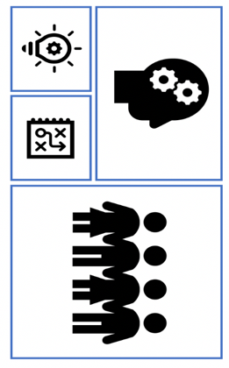
#3 (morse) Learn from a model
#4 (snote) Develop puzzles from content
#5 (rebus) Practice Makes Perfect
Code: 2PLAY

Shelesky et al, Escaping the Average Teaching Technique, STFM Annual Conference, 2019

#1 #2 puzzle (gather a team, explain roles, brainstorm together, split tasks)
#3 (morse) Learn from a model
#4 (snote) Develop puzzles from content
#5 (rebus) Practice Makes Perfect
CODE: 2PLAY

Shelesky et al, Escaping the Average Teaching Technique, STFM Annual Conference, 2019

2 P L A Y
2 P L A Y

