Identifying and Resolving Conflict:
helping residents learn the basics
Six (6) Steps to Managing Conflict
1. Seek to understand
2. Discuss face-to-face
3. Stick to the issues
4. Check your emotions & attitudes
5. Speak for yourself
6. Use time to mutual advantage

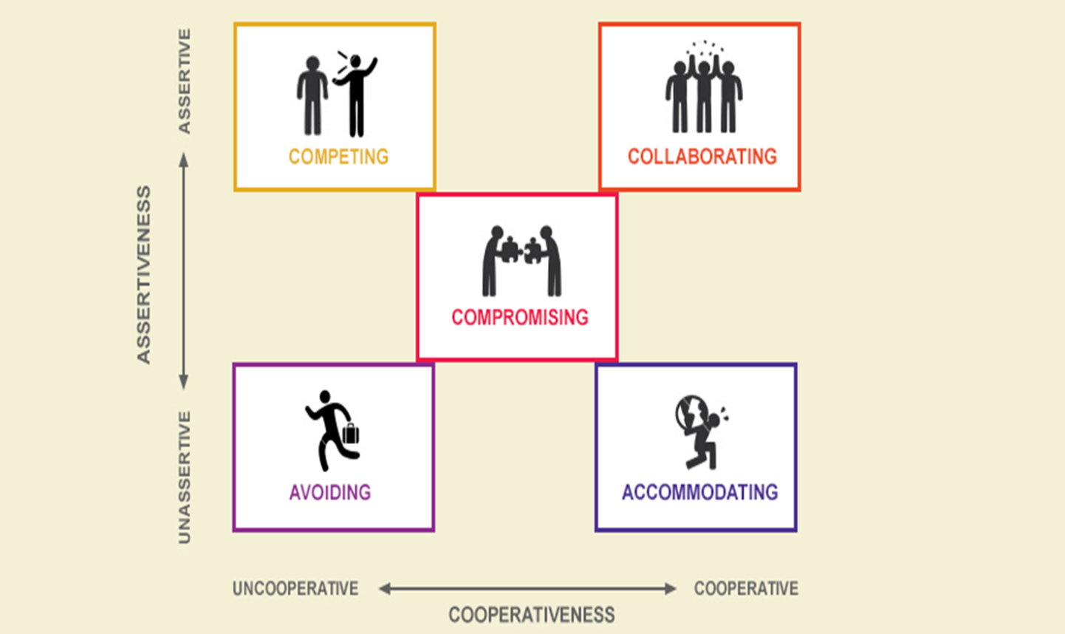
TKI (Thomas Kilmann Conflict Mode Instrument)
https://workshopbank.com/conflict-resolution-strategies

LADDER OF INFERENCE
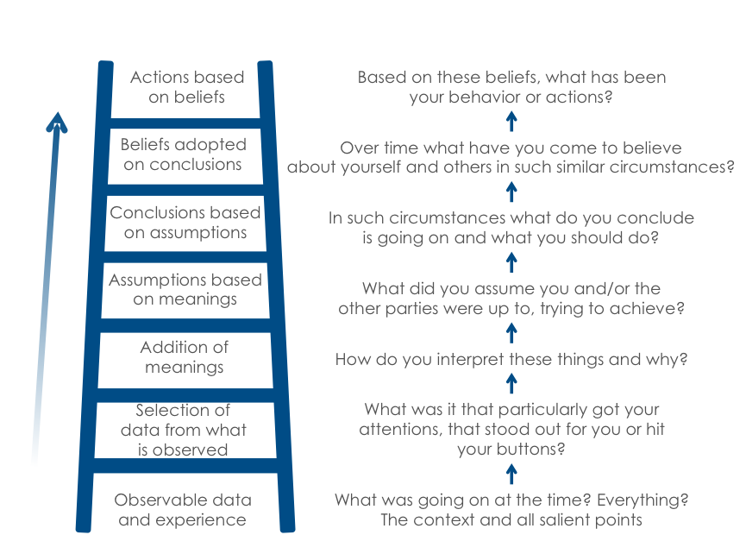

This seminar has been uploaded, (http://resourcelibrary.stfm.org/home)
and you are free to use
the information with credit to original presenters.

If you have additional questions, feel free to contact us”
Deborah Taylor, PhD taylord@cmhc.org
Donald “Raj” Woolever, MD woolevra@cmhc.org

