Breakout Group 1 – Case 1 Discussion Questions
- 9 minutes: Intro & Reflect
  - Introduce self and position in residency practice. Tag the next person to share.
  - Share your self-reflection: your emotional reaction and what you felt pulled to do?
  - How did your impulse differ from what the BH faculty did?
- 6 minutes: Ethical Dilemmas - use the table on the next page as guide.
- Discuss the ethical conflicts and dilemma’s this brings up for the BH faculty and the resident.

Breakout Group 2 – Case 2 Discussion Questions
- 7 minutes: Take the perspective of your medical colleague and answer the questions
  - What might your physician colleague be feeling (emotionally or physically) or thinking about during this dialogue with you?
  - Consider your colleagues' priorities in this situation? What are the unmet needs they may be trying to fulfill?
- 3 minutes: Ethical Dilemmas: Use the table on the next page
  - Discuss the ethical conflicts and dilemma’s that are evident in this scenario for the providers.
- 5 minutes: How would you approach closing the loop and discussing the ethical dilemma with your colleague?
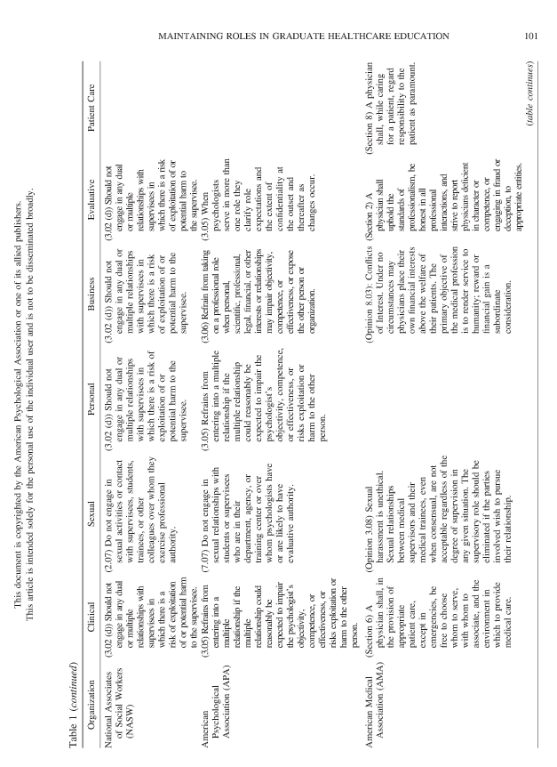
Reitz R, Simmons PD, Runyan C, Hodgson J, Carter-Henry S. Multiple role relationships in healthcare education. Fam Syst Health. 2013;31(1):101. doi:10.1037/a0031862

