Micronutrient Lecture – Survey Tool
Dr. Jo Marie Reilly, MD, MPH
Kevin Robinson, BS

Note – Questions 1-8 were administered for all 3 survey iterations. Questions 9-11 were only given post-lecture and at 3-month follow-up.

Please provide the last 4 digits of your cell phone number (to help us anonymously compare pre-post survey data)

___________________________________(Short answer text)___________________________________

- Which of the following is the leading cause of blindness in children worldwide?

- Glaucoma
- Vitamin A Deficiency
- Vitamin B12 Deficiency
- Infants who are fed formula without vitamin C supplementation

- Which of the following mineral supplements is now being recommended for all children starting at 6 months of age?
- Copper
- Iodine
- Iron
- Fluoride
- Zinc

- At one time, the disease rickets had all but disappeared from the U.S. Now, rickets is making a comeback. Which infants are most likely to get rickets?
  - African American infants who are breastfed
  - Causasian infants who are breastfed
  - Hispanic infants who are breastfed
  - Any infant who is fed formula

- Which of the following can occur in pregnant women with folate deficiency?
  - Developmental delays including austism
  - Neural tube defect
  - Premature birth
  - Congenital heart disease
  - Cleft lip palate

Please state the extent that you agree with the following statements:

- I feel confident in my ability to assess nutritional deficiencies at various stages across the life cycle.
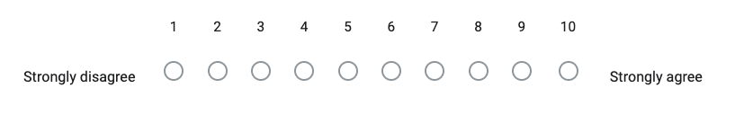

- I feel confident in my ability to counsel patients on nutrition

- I think that more nutrition content should be included in the medical school curriculum

- Learning more about nutrition motivates me to change my own personal dietary behaviors

- I feel that this lecture was worthwhile and taught me information that will help me counsel future patients

- How will you change your own dietary behaviors after receiving this lecture?

___________________________________(Short answer text)___________________________________

- How will you counsel your patients differently after receiving this lecture?

___________________________________(Short answer text)___________________________________

