Appendix 1. Post-Volunteer Survey

Q1. On average, how many hours per week did you spend on this project?

Q2. Please respond to the following statements. I feel that…
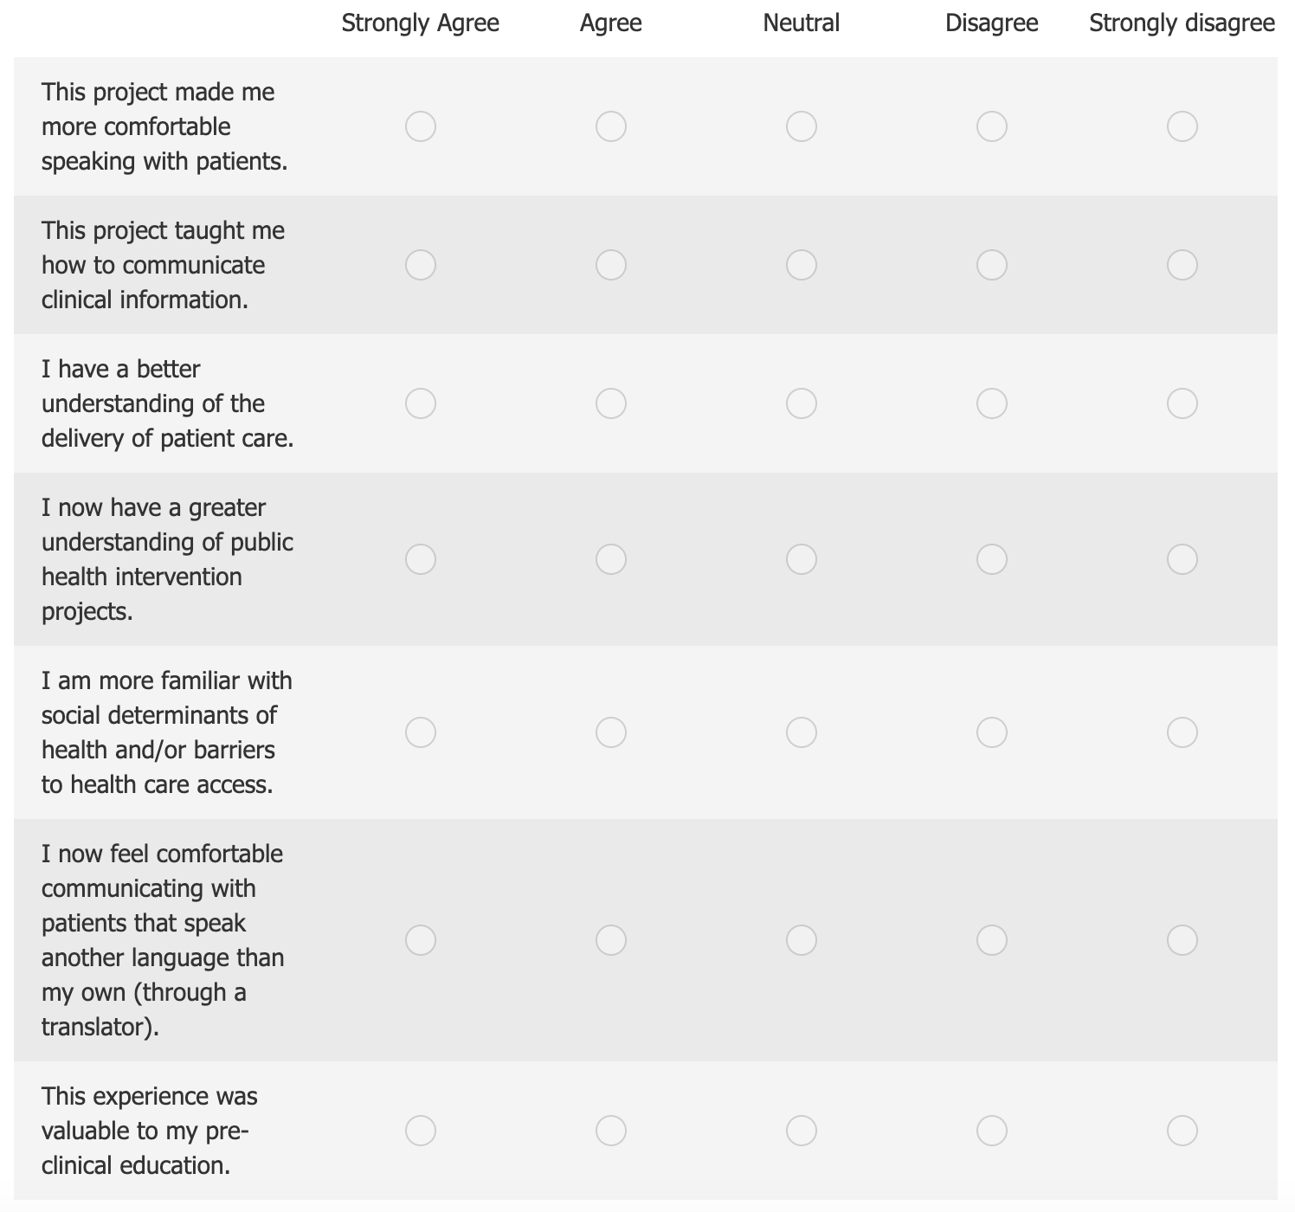

Q3. What do you think went well with this project?

Q4. What do you think could have been improved about your learning experience?

Q5. Please feel free to include any additional comments or feedback.

