FEEDBACK CASE 3: RESIDENT
You are working a normal clinic day when a transgender pediatric patient is scheduled for a school physical. Your medical student repeatedly calls your patient by the wrong pronoun, and the patient seems distressed by the situation. The patient eventually will only respond with short answers and is unwilling to engage with the providers. You recognize that you should correct the medical student so that this does not happen again.

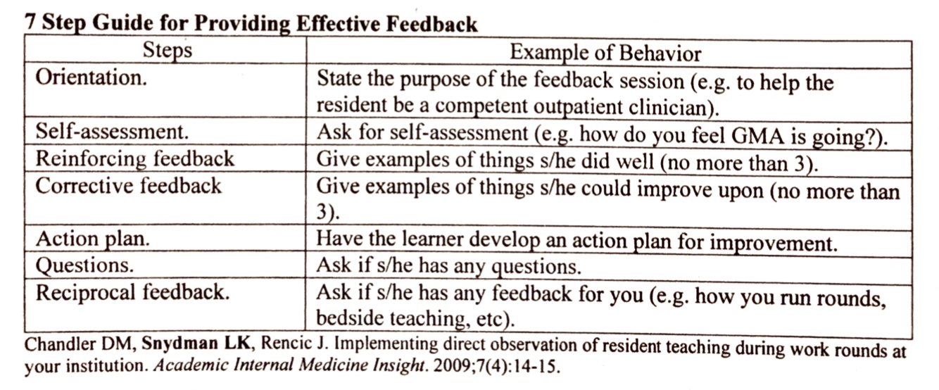

Sample Responses for Feedback
Feedback Steps | Sample response
Orient the student to feedback | This is a feedback session. My goal is to help you succeed as you move on in this clerkship and with the rest of medical school.
Ask for a self-assessment | How do you think you did today?
Reinforcing feedback (no more than 3) | You appropriately identified the screening and history taking needed for the visit.
Corrective feedback (no more than 3) | I noticed that the patient looked uncomfortable as the history taking went on, and looking through the chart, it looks like the patient uses different pronouns and goes by a different name. What I like to do with all of my patients is ask how they liked to be called when I first meet them. That makes them feel comfortable and makes sure that I am using the right name and pronouns. I think this would have made our encounter go more smoothly.
Action plan (learner developed) | Thinking about how things went today, what is something you can change for next time?
Questions | Do you have any questions or clarifications for me?
Reciprocal Feedback | Do you have any feedback on my feedback, or about anything else you saw today in clinic with me?

The goal of this case is to emphasize how to provide corrective feedback. Corrective feedback should focus on addressing high priority issues. In cases where you may feel uncomfortable initiating the conversation, the use of “I” statements can be helpful: base your feedback on things you directly observed.
Corrective feedback should include suggestions for improvement. You can listen to excuses, but at the end of the day, it is important to still give the feedback that is needed to help the learner improve.

FEEDBACK CASE 3: MEDICAL STUDENT
You are working a normal clinic day and the resident asks you to see a well child visit. You review their labs to see what they are due for and what screenings you should perform. You introduce yourself and take the history. You make sure to talk with both the patient and their parent, and address them by the name listed in the EMR. As the visit goes on, you feel that the patient becomes less and less engaged in your history taking. You are aware that something didn’t go right but you’re not sure what it was.

Feedback Steps | Sample response
Orient the student to feedback | n/a
Ask for a self-assessment | I feel like something was off and I wasn’t connecting with the patient like I usually do.
Reinforcing feedback (no more than 3) | n/a
Corrective feedback (no more than 3) | n/a
Action plan (learner developed) | I did not realize I was using the wrong name or pronouns. I will try to ask in the future.
Questions | Up to you (the roleplay student)
Reciprocal Feedback | Up to you (the roleplay student)

