Table 1. Instruments Measuring Different Dimensions of Well-Being
Instruments | Dimension | Components | Comments | Link to Instrument
Maslach Burnout Inventory | Mental | Emotional exhaustion; Depersonalization;  Personal accomplishment | $15pp; $200/group  Free for AAFP members*; 2-22 items; benchmarks; relevant to team | https://www.mindgarden.com/315-mbi-human-services-survey-medical-personnel#horizontalTab3*
Stanford Professional Fulfillment Index | Mental | Work exhaustion; Interpersonal disengagement;  professional fulfillment | 9 items; free to individuals; expensive to programs; benchmarks to US docs; relevant to team | https://www.ncbi.nlm.nih.gov/pmc/articles/PMC5794850/
Physician Wellness Inventory | Mental | Career purpose, stress, cognitive flexibility | 14 items; free, | https://www.plasticsurgery.org/documents/medical-professionals/wellness/Physician-Wellness-Inventory.pdf
Mini-Z | Mental and circumstances | Single-item burnout assessment and institutional stressors | 16 items; free; benchmarks to US docs; relevant to team | https://www.stepsforward.org/Static/images/modules/15/downloadable/Mini%20Z%20burnout%20survey.docx
Oldenburg Burnout Inventory | Mental | Exhaustion; Disengagement from work | 16 items; relevant to team | https://pdfs.semanticscholar.org/1199/89bafadcb75a9b3f85acff0611b3e429ee9f.pdf
Perceived Stress Scale | Mental | Feelings and thoughts within the past month | 7-10 items; free; benchmarks to US docs; relevant to team; does not consider context | http://www.mindgarden.com/documents/PerceivedStressScale.pdf
Brief Resilience Scale | Mental | How one manages stress | 6 items | https://ogg.osu.edu/media/documents/MB%20Stream/Brief%20Resilience%20Scale.pdf
Interpersonal Reactivity Index | Mental | Perspective taking, fantasy, empathic concern and personal distress | 35 items: 7 for each subscale | https://fetzer.org/sites/default/files/images/stories/pdf/selfmeasures/EMPATHY-InterpersonalReactivityIndex.pdf
Short Grit Scale | Mental | Perseverance and passion for long term goals | 8 items | http://www.sjdm.org/dmidi/files/Grit-8-item.pdf
Hair Cortisol | Physical | Short and long term cortisol | $35/sample | https://stresscenter.ucsf.edu/measures/hair-cortisol
Welltory App | Physical | Heart rate variability through smart phone camera | 5 days free, then monthly fees; easy to use –no added equipment needed; useful for formative feedback | https://apps.apple.com/us/app/welltory-your-personal-health/id1074367771
HeartMath and Inner Balance App | Physical | Heart rate variability through sensor | $129-$159 for app and sensor; useful for formative feedback | https://store.heartmath.com/innerbalance?_ga=2.65768046.1181636718.1563379190-328316990.1452981517#btle
ProQ0l questionnaire | Social | Positive and negative of helping others | 5 items; free; multiple translations available | https://proqol.org/ProQol_Test.html
Brief Team Survey | Social and circumstances | Roles, tasks and communication | 5 items | https://fammedarchives.blob.core.windows.net/imagesandpdfs/fmhub/fm2011/November/Stephen731.pdf
Work Limitation Questionnaire | Activities and functioning | 4 domains of health interference with productivity | 8-25 items; proprietary (Tufts) | https://www.tuftsmedicalcenter.org/Research-Clinical-Trials/Institutes-Centers-Labs/Center-for-Health-Solutions/Available-Questionnaires
Kentucky Inventory of Mindfulness Skills | Activities and functioning and Mental | 4 subscales on observing, acting with awareness, describing, and non-judgement | 39 items | http://www.ruthbaer.com/academics/KIMS.pdf
FANTASTIC Lifestyle Assessment | Activities and functioning | Family, activity, nutrition, toxins, alcohol, sleep, personality type, insight, career | 9 items | https://www.ncbi.nlm.nih.gov/pmc/articles/PMC2153572/pdf/canfamphys00221-0095.pdf
Pittsburgh Sleep Quality Index | Activities and functioning | Seven domains of sleep | 10 items | https://www.opapc.com/uploads/documents/PSQI.pdf
Physical Activity Assessment Tool | Activities and functioning | Type, frequency and duration of physical activity in past 7 days | 7 items | https://www.aafp.org/afp/2008/0415/afp20080415p1129-f1.pdf
*Maslach Inventory for AAFP members: https://www.aafp.org/membership/benefits/physician-health-first/faqs.html
Table 2. Drivers of Burnout and Engagement (Shanafelt, 2017)
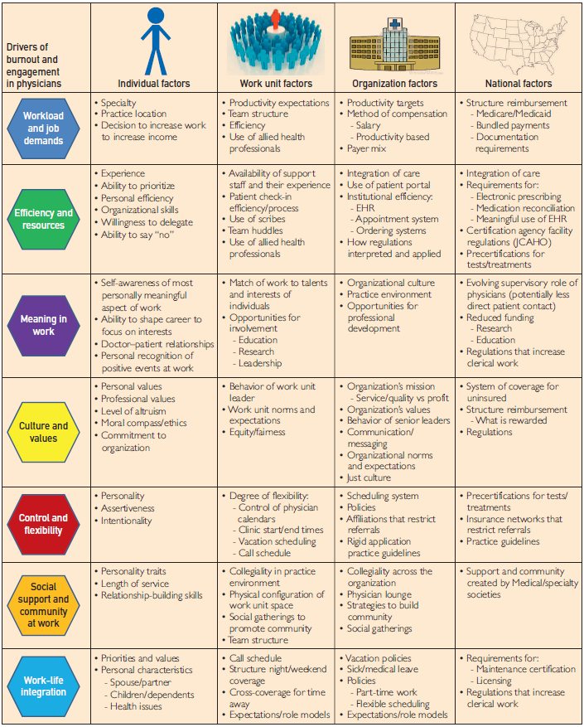

References
Baer, RA, Smith, GT, Hopkins, J, Krietemeyer, J & Toney (2006). Using self-report assessment methods to explore facets of mindfulness. Assessment, 13, 27-45. (Kentucky Mindfulness Inventory).

Buysse, DJ, Reynolds, CF, Monk,TH, Berman, SR, & Kupfer, D.J. (1989). The Pittsburgh Sleep Quality Index (PSQI): A new instrument for psychiatric research and practice. Psychiatry Research, 28(2), 193-213.

Cohen S, Kamarck T, Mermelstein R. (1983). A global measure of perceived stress. Journal of Health and Social Behavior, 24, 385-396. (Perceived Stress Scale).

Eckleberry-Hunt JG, Kirkpatrick H, Taku K, Hunt R, Vasappa R, Essian J. What makes a physician well: development of the Physician Wellness Inventory. Presented at: Society of Teachers of Family Medicine 45th Annual Spring Conference; April 27, 2012; Seattle, WA.

Halbesleben JRB, Demerouti E. The construct validity of an alternative measure of burnout: investigating the English translation ofthe Oldenburg Burnout Inventory. Work Stress. 2005;19(3):208-220.

Linton M-J, et al. (2016). Review of 99 self-report measures of well-being in adults; exploring dimensions of well-being and developments over time. BMJ Open 2016;1-16. doi:10.1136/bmjopen-2015-010641

Lurie, SL, Schultz, SH and Lamanna, G. (2011). Assessing Teamwork: A Reliable Five-Question Survey. Fam Med. 43(10):731-4.

Meriwether RA, McMahon PM, Islam N, Steinmann WC. (2006) Physical activity assessment: validation of a clinical assessment tool. Am J Prev Med. Dec;31(6):484-91. Epub 2006 Nov 3.

Noben, CYG, Sivlia, MAAE, Nijhuis, FJ and de Rijk, AE. Quality Appraisal of generic self-reported instruments measureing health related productivity changes: a systematic review. BMC Public Health 2014, 14:115. http://www.biomedcentral.com/1471-2458/14/115

Shanafelt, TD and Noseworth, J. (2017). Executive Leadership and Physician Well-being:
Nine Organizational Strategies to Promote Engagement and Reduce Burnout. Mayo Clin Proc. 2017;92(1):129-146.

Valid and Reliable Survey Instruments to Measure Burnout, Well-Being, and Other Work-Related Dimensions. (n.d.). Retrieved March 1, 2019, from National Academy of Medicine website: https://nam.edu/valid-reliable-survey-instruments-measure-burnout-well-work-related-dimensions/

