Decode this Rebus puzzle to find 2 popular electronic resources.
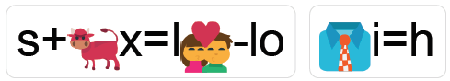
See the facilitator to confirm you are correct to receive your piece of the final puzzle for this station.
Example: Solve the puzzle =
S + (ox, where x = l) (love – lo) = SOLVE (tie, where i=h) = THE P+ (up, where p=z) + z + (left – ft) = PUZZLE

☀n=r+🔑k=v 🍋-le🔑

g+🐕d=o+⬅-ft f+🐂x=r+m
Shelesky et al, Escaping the Average Teaching Technique, STFM Annual Conference, 2019

