Recent FMIS Team
Strengths Assessment

Myers-Briggs
Role/  Name | Extraversion vs. Introversion | Sensing vs. Intuitive | Thinking vs. Feeling | Judging vs. Perceiving
PGY3 Senior  P3 | I  (2/19) | N  (7/19) | F  (0/24) | P  (7/15)
PGY2 Senior  P2 | E  (12/9) | N  (6/20) | F  (2/22) | P  (2/20)
OB Intern  OB | E  (19/2) | N  (0/26) | F  (0/24) | P  (0/22)
Intern 1  1 | I  (9/11) | N  (11/13) | F  (8/15) | J  (19/2)
Intern 2  2 | E  (12/8) | S  (17/8) | T  (16/7) | P  (8/13)
Intern 3  3 | E  (13/8) | N  (5/21) | F (T??)  (10/14) | J  (14/8)
Intern 4  4 | I  (6/15) | N  (1/25) | F  (10/14) | J  (12/10)

Birkman Method
Task Oriented
People Oriented
Extroversion
Introversion
Introversion
Extroversion

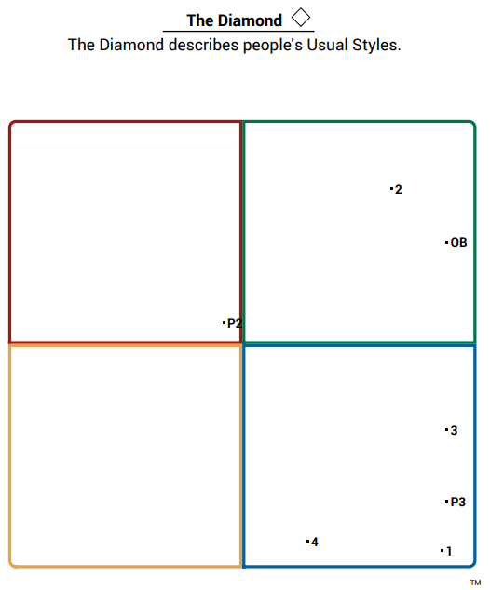
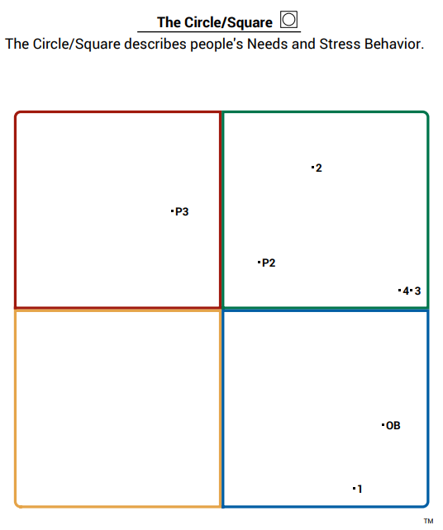

Whole Team Dynamics
- Intern 2 is the only Sensing person on a team of people who prefer Intuition. This means that he is more interested in details than the big picture. This is a strength and will likely be helpful for the team, but it is possible that he will feel frustrated at the lack of details given in discussions about patients.
- Intern 2 (and possibly Intern 3) is the only Thinker on a team of Feelers. This means that he prioritizes using logic and reason when considering information and making decisions, while the rest of the team prioritizes values and feelings first. Use his strength to the team’s advantage and be aware of frustrations that may arise with different approaches.
- You are both Perceivers while Intern 1, Intern 3, and Intern 4 are all Judgers. This means that you are more likely to have flexibility in your planning and to leave room for changes once a decision is made than they are. This has the potential of being frustrating for all parties.
- Intern 3 needs a healthy sense of competition in order to thrive.
- OB Intern has a lot of energy, but is likely to take too much on and actually needs more unscheduled, relaxed time than she might realize. Encourage her to rest and take breaks when able. It is also important for OB Intern to have space to express her feelings and to feel respected by people in authority.
- Intern 4 also needs space to express his feelings, as well as to feel respected by people in authority. Intern 4 needs to know who is in charge. Intern 4 does better when allowed to make his own plan for how to go about work. Intern 4, like Intern 3, needs a healthy sense of competition to thrive. Intern 4 needs variety in tasks.

Senior Dynamics
- Your Myers Briggs is very similar with the exception of Introversion/Extroversion. PGY2 likely needs more time with the group and PGY3 benefits from one-on-one time or alone time. Given that your Myers Briggs is otherwise similar, you can likely understand where the other is coming from, but likely have the same areas of weakness/blind spots. Be aware of these as you work together.
- PGY3 needs more direct communication than her usual style. She needs to have plenty to do and prefers to be given clear-cut decisions to be made. This is similar to how PGY2 usually interacts with others, so it will likely come naturally for him and be a good fit.
- No significant differences to watch noted on the Birkman.

PGY3 with the Interns – Differences to Watch
- You are more direct and assertive than OB Intern. She is unlikely to offer ideas unless specifically invited to do so. She prefers to keep relationships pleasant and prefers suggestions rather than direct supervision.

PGY2 with the Interns – Differences to Watch
- You are more direct and assertive than OB Intern. She is unlikely to offer ideas unless specifically invited to do so. She prefers to keep relationships pleasant and prefers suggestions rather than direct supervision.

