Apply
Understand
Evaluate
Remember
Create
Analyze
Apply
Understand
Evaluate
Remember
Create
Analyze

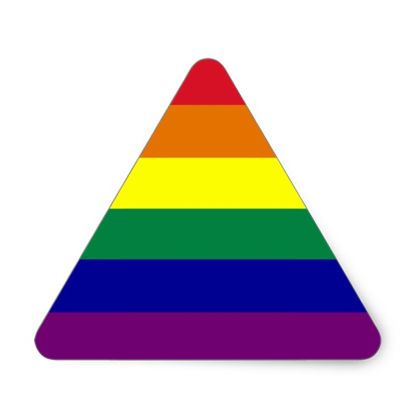
Use Bloom’s Taxonomy to craft learning objectives in the Kemp model. Complexity increases with each level.
Arrange categories from lowest (purple) to highest (red) complexity. Bring your answer to your facilitator.
**Cannot use iPhone/Accessory Brain for the first try

Shelesky et al, Escaping the Average Teaching Technique, STFM Annual Conference, 2019

