Elevator Breathing
Deep breathing can be like riding an elevator. Start the elevator ride by breathing in through your nose all the way up to the top floor. As you breathe out, feel the breath travel all the way down to the basement, where your toes are.

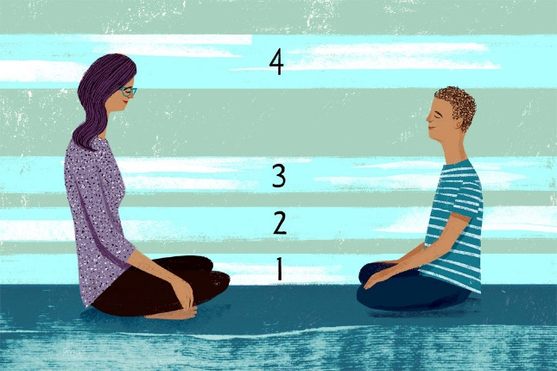
Breathe in and take your breath up to the first floor, your belly. Hold it. Now breathe out all your air.

Breathe in and take your breath up to the second floor, your chest. Hold it. Now breathe out all your air.

Breathe in and take your breath up to the third floor, your smile. Hold it. Now breathe out all your air.

Now breathe in and take your breath up to the top floor, up your throat and into your cheeks and forehead. Feel your head fill with breath. Hold it.

Now breathe out and feel all your troubles and worries leave your body and go out the elevator door.

Created from multiple sources by RBK: Richard.Brandt-Kreutz@providence.orgr

