Dermatology Pictures

Cypher: Reverse Alphabet EXCEPT: a=p; p=a; k=z; z=k

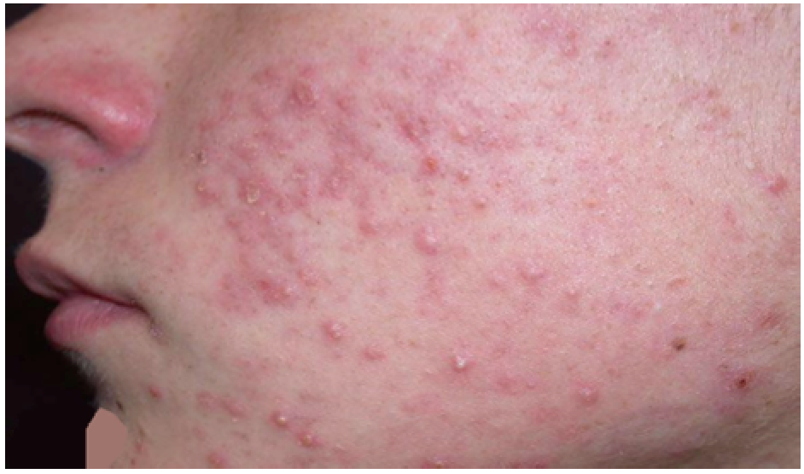
acne = pxmv

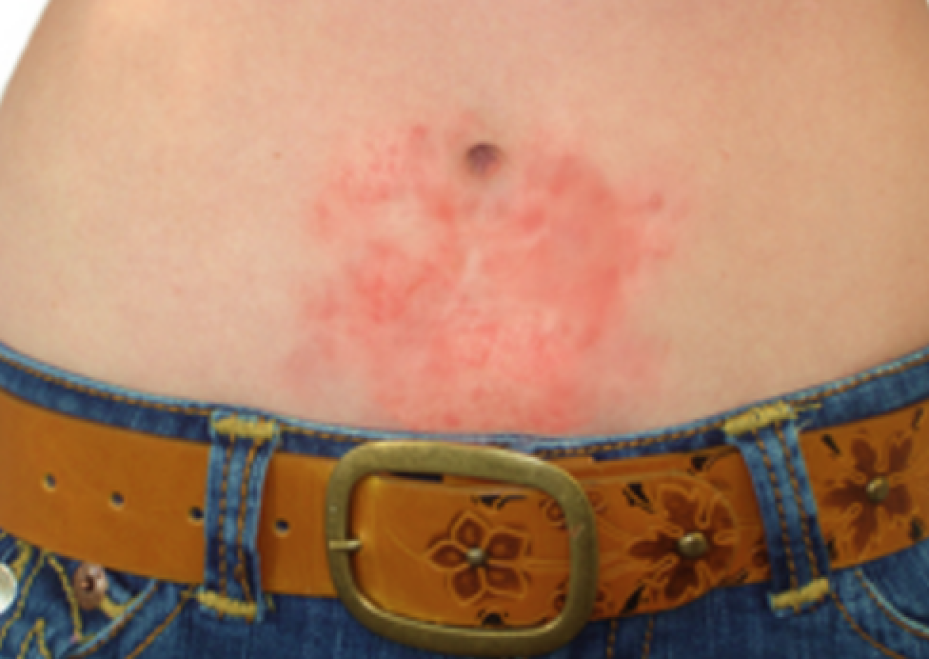
contact dermatitis = xlmgpxg xvinpgrgrh

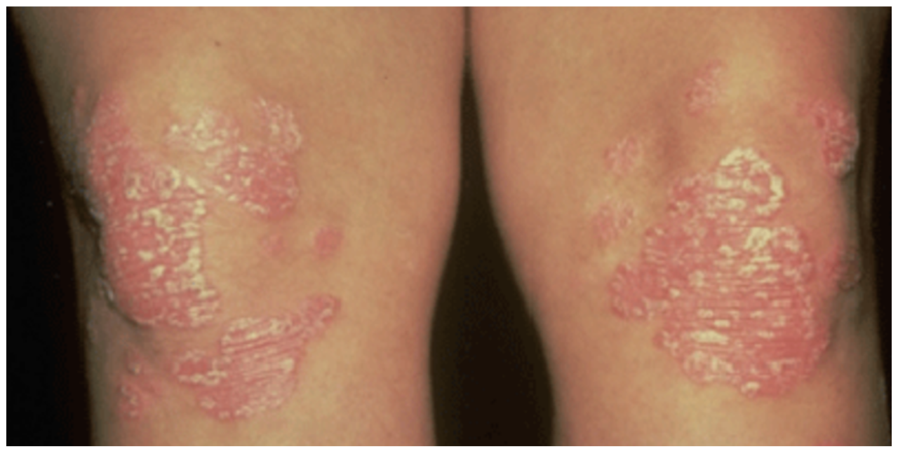
psoriasis = ahlirphrh

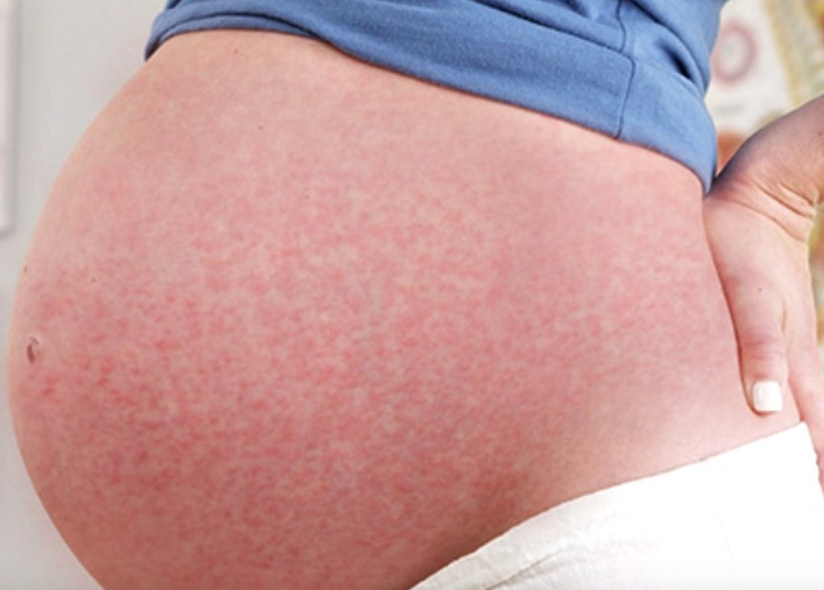
pupps = afaah

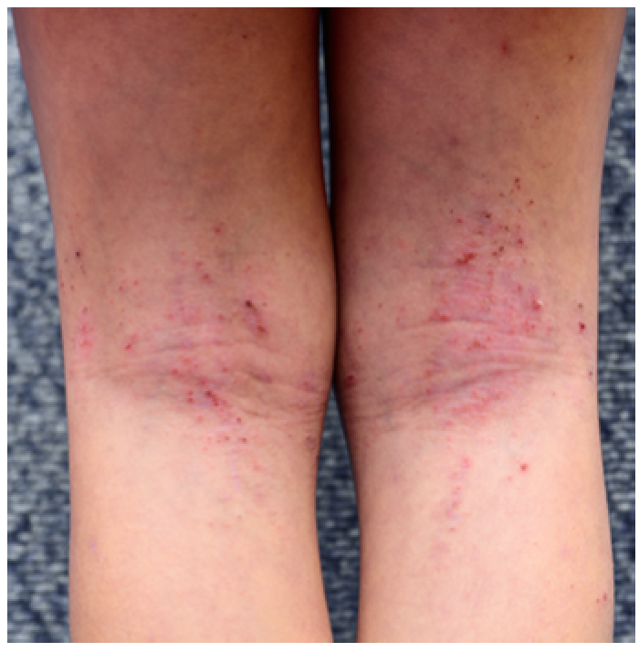
eczema = vxkvnp

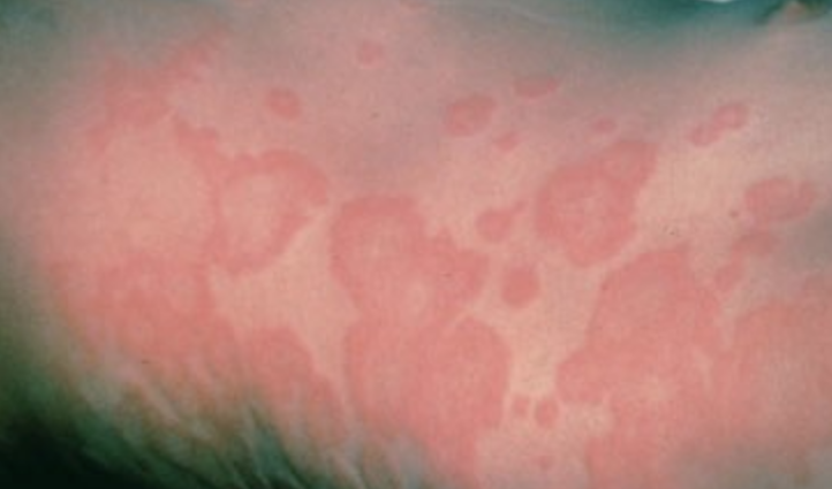
hives = srevh

