#1 Invisible Ink Pens and UV Lights (4/Pack) $5.88 – Walmart #4 Index cards ($1 Dollar Tree)
LED UV Flashlight $12.34 – Walmart 2 locks ($10 walmart or home depot)
Assorted Color Index Cards (100/Pack) $2.91 – Amazon Envelopes ($3.65 Walmart, $1 Dollar Tree)
Manilla Envelopes (100/Pack) $14.98 – Sam’s Club You (Free, well kind of)
Master Lock Combination Locks (Each) $4.98 – Home Depot (Some resources to check out: Amazon, Target
Speed Dial Set-Your-Own Combination Padlock $7.98 -Home Depot Walmart, Dollar Tree, Family Dollar)

#2 (directions) down, left, right, up #5 Envelope Hiring
(letter not on periodic table) J QR codes Paying for software
Using yourself Safe Box
#3 1-2 X’s or circles 3-4 X’s or circles 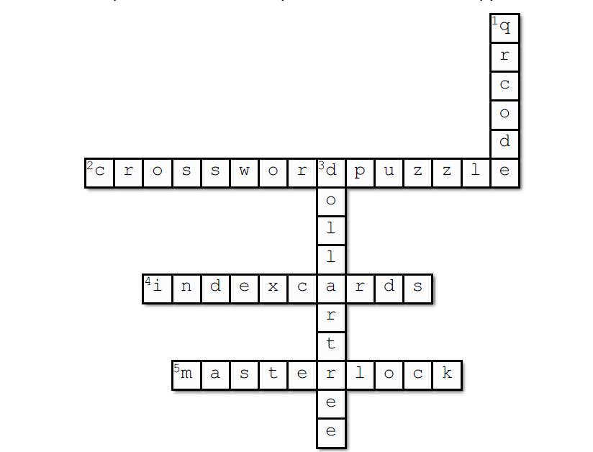

#1 Invisible Ink Pens and UV Lights (4/Pack) $5.88 – Walmart #4 Index cards ($1 Dollar Tree)
LED UV Flashlight $12.34 – Walmart 2 locks ($10 walmart or home depot)
Assorted Color Index Cards (100/Pack) $2.91 – Amazon Envelopes ($3.65 Walmart, $1 Dollar Tree)
Manilla Envelopes (100/Pack) $14.98 – Sam’s Club You (Free, well kind of)
Master Lock Combination Locks (Each) $4.98 – Home Depot (Some resources to check out: Amazon, Target
Speed Dial Set-Your-Own Combination Padlock $7.98 -Home Depot Walmart, Dollar Tree, Family Dollar)

#2 (directions) down, left, right, up #5 Envelope Hiring
(letter not on periodic table) J QR codes Paying for software
Using yourself Safe Box
#3 1-2 X’s or circles 3-4 X’s or circles

Shelesky et al, Escaping the Average Teaching Technique, STFM Annual Conference, 2019

